I have been sailing with my Dad on the Spray (No. 19) since I was 18 months old and especially enjoy ‘sleeping over’. I was really excited when Dad said we were going to the International Festival of the Sea for 3 days and would be staying in the historic dockyard.

We set sail from Beaulieu on the morning of the 30th of June and had the wind behind us all the way, it was a bit ‘rock and rolly’ and Mum was getting a bit nervous by the number of big boats and ferries coming out of Portsmouth harbour. As we approached the narrow small boat channel Dad put the engine on and took down the sails. To Mum’s horror the engine wasn’t making us go forwards. Dad checked over the stern and saw a huge lump of seaweed round the propeller, so up went the sails and off with the engine. We turned round, back out to open water so Dad could clear the propeller. Mum was getting a bit “excited” to say the least. She really must wear her glasses when she is on the helm. With propeller cleared we tried again. It was very busy. We entered the dry dock number 11. It wasn’t dry to my surprise. We moored alongside a floaty pontoon which was great for jumping up and down on (when Dad wasn’t looking). We only saw one other Shrimper and that was Eclipse from Bosham. Everyone we met was really friendly.
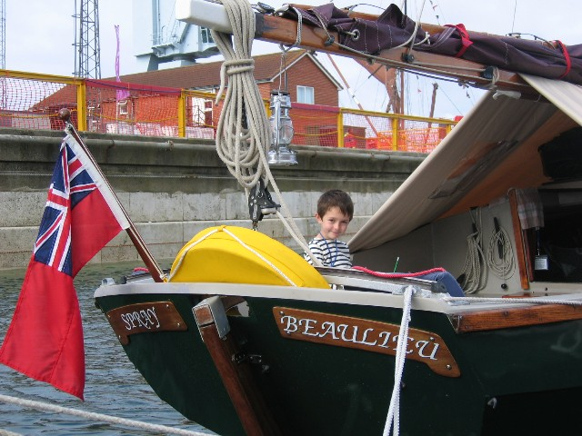
The next 3 days were fantastic. I really enjoyed Nelson’s Ship Victory and also the tall ships and wondered what it would be like to sail on a big boat. The crew centre was really cool too, especially as the chips were cheap and Dad said the beer was good value for money. It must have been because he seemed to make the most of it.

One morning while we were having the usual bacon buttie breakfast onboard, we were approached by a Viking with long hair and a beard. He was going out on the replica Saxon Ship ‘Sae Wyfling’. Apparently Dad went to school with the Viking and hadn’t seen him for 25 years. I know Dad has a Shrimper but I didn’t think he was that old !

We had intended to stay for only 3 days but were unable to see everything, so to my delight we stayed for an extra day. My best memories will be meeting Nelson (although I did see him in Yarmouth at Old Gaffers as well), the Walk the Plank theatre ship with the tale of Noah’s Ark and Dad being impressed with the bar in the funnel, B(ig) & Q(uick), the Sea Shanty stage, Anchor Lane, the bouncy castles, Punch and Judy and many other things.
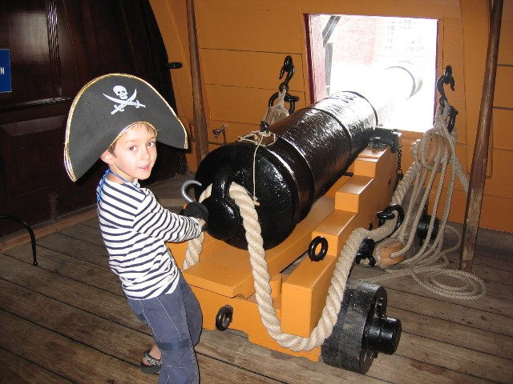
I was sad to leave Portsmouth very very early on the Monday morning. In fact I stayed in my bunk and didn’t wake up until we were off Lepe. When we got home I put together a scrap book for school as I had been allowed the time off. I am already looking forward to the next Festival of the Sea. Thanks Dad. It was brilliant !

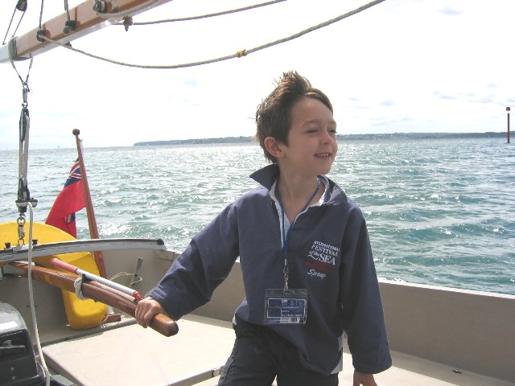

PS. Dad says he will probably get told off for the picture as I don’t have my life jacket on. I only took it off for the photos. I do have my level 4 swimming badge but Dad still makes me wear my life jacket and I even have to put a safety line on if I go up for’ard.

Fyn Mitchell aged 6.

